A certificate authority is a trusted entity that verifies domain ownership and issues digital certificates. This process helps establish trust between websites and their users. CAs play an important role in online security because they help prevent attackers from impersonating legitimate websites, such as banks, and enable secure HTTPS connections through Transport Layer Security (TLS). TLS protects sensitive information, including passwords and financial data, from interception or alteration during transmission (Let's Encrypt, n.d.).
One major benefit of using a CA is that web browsers can quickly verify certificates through trusted certificate chains. This allows users to trust a website's identity without having to verify it themselves. CAs can also provide services such as certificate renewal, revocation, and automation, making certificate management easier for website owners. For example, Let's Encrypt offers free TLS certificates, helping website owners implement HTTPS at no additional cost (Let's Encrypt, n.d.). Although self-sign certificates can be useful for development and testing environments, certificates issued by trusted CAs are generally a better choice for public-facing production websites because web browsers do not automatically trust self-signed certificates (Oracle, n.d.).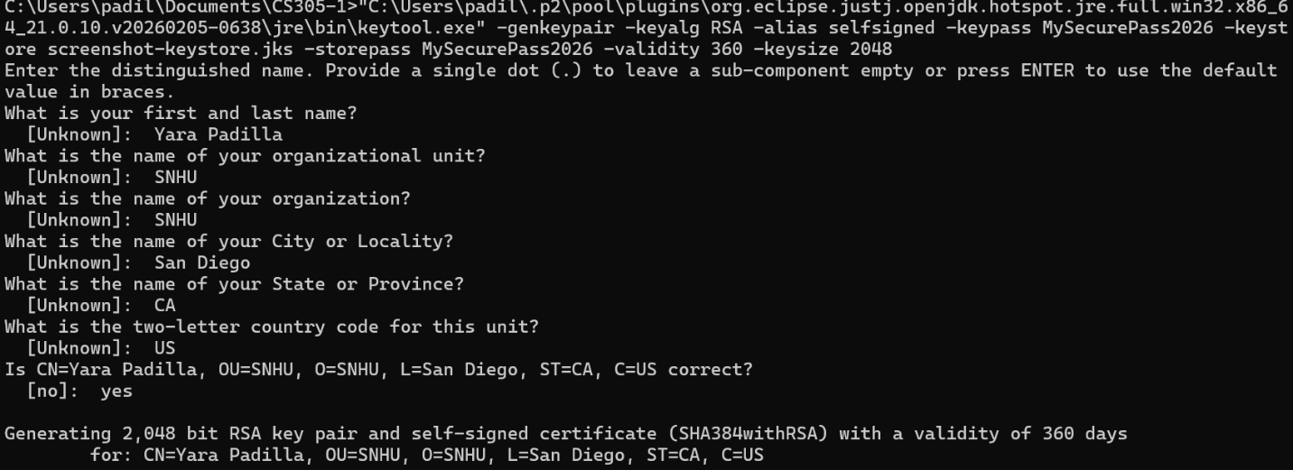
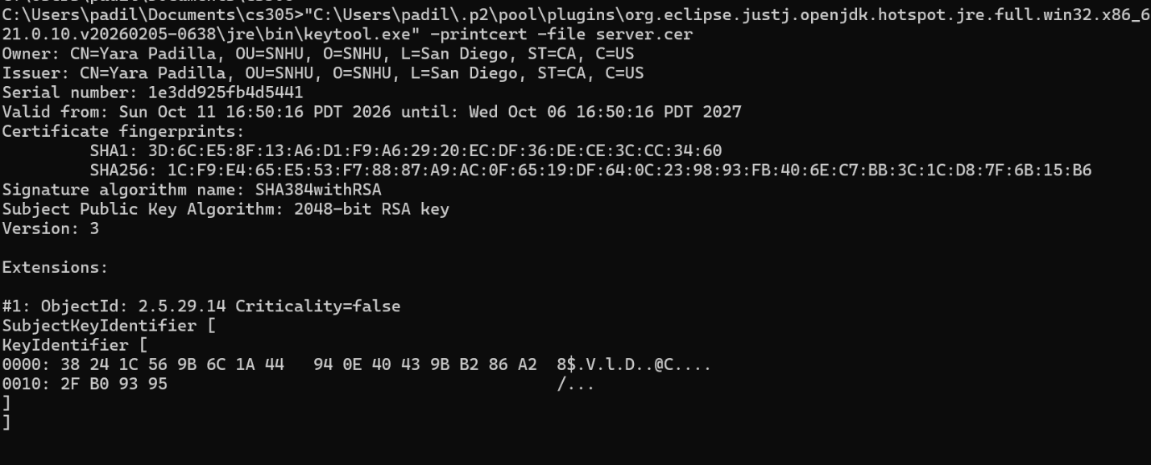

References:
Let's Encrypt. (n.d.). How it works. Let's Encrypt. https://letsencrypt.org/how-it-works/
Oracle. (n.d.). The keytool command. Oracle. https://docs.oracle.com/en/java/javase/21/docs/specs/man/keytool.html

